Unified Logic - Compliance Management
UNECE R155 (CSMS) | UNECE R156 (SUMS) | ISO/SAE 21434 (Cybersecurity Engineering)
Date: 19 Jan 2026

1. Executive Summary
Unified Logic is a secure automotive telematics platform that captures OBD/ECU diagnostic data on an edge device (Raspberry Pi), generates tamper-evident integrity proofs (hashing + Merkle root), anchors proofs to a public distributed ledger (Polygon), stores a private integrity manifest locally, and verifies consistency in the cloud (AWS). The product also supports secure Over-The-Air (OTA) software/model updates using AWS IoT Jobs (MQTT) with signed release packages.

2. Compliance Approach
This document demonstrates compliance alignment rather than formal certification. UNECE R155 and UNECE R156 type approval certifications are performed by OEMs under regulated audit programs. As a hackathon product, our goal is to show: (a) the cybersecurity and update controls we implemented, (b) how these controls map to the standards, and (c) the evidence artifacts produced by the system that judges can verify during the live demo.

3. Why We Implemented Compliance Controls
- Prevent tampering of vehicle diagnostic data during capture, transmission, storage, and analytics.
- Provide cryptographic integrity proof (tamper evidence) that is independently verifiable.
- Enable controlled and secure patching through signed OTA updates for edge devices.
- Align with real-world automotive cybersecurity and software update requirements used by OEMs and fleets.

4. Product Scope and System Boundaries
Unified Logic focuses on two major functions:
- Telematics integrity: OBD/ECU data batching, Merkle root creation, private manifest storage, public blockchain anchoring, and cloud verification.
- Secure OTA: Signed release distribution from AWS to Raspberry Pi via AWS IoT Jobs over MQTT, with device-side verification and status reporting.

5. Implemented Security Architecture (What We Built)
- OBD data is collected and sent via TCP to Raspberry Pi.
- Pi batches 8 records per batch and computes hashes + Merkle root.
- Pi creates a private integrity manifest (Merkle root, Merkle proofs, timestamp, batch ID).
- Merkle root is anchored to Polygon (public DLT) to obtain a transaction ID (TxID).
- Signed evidence/manifest bundle is stored in a dedicated S3 location.
- EC2 verification service recomputes integrity and validates: private manifest == S3 evidence == public DLT anchor.
- OTA updates are built (SageMaker pipeline), signed, uploaded to S3, and distributed using AWS IoT Jobs via MQTT.
- Pi verifies signature + hash before switching to the new version, restarts the service, and reports status back to IoT Jobs.

6. Evidence Artifacts Generated
During the demo, the following artifacts provide evidence of implemented security controls:
- Merkle root per batch (computed on Pi).
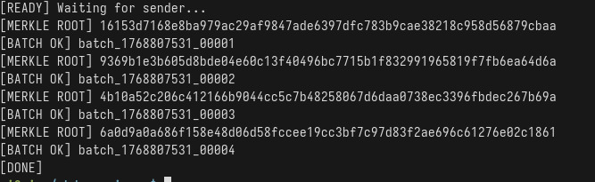
- Private DLT manifest entry: {batchId, timestamp, merkleRoot, merkleProofs, txRef}.
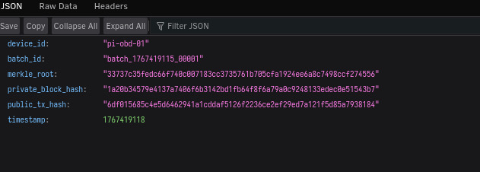
- Polygon transaction hash (TxID) anchoring the Merkle root.
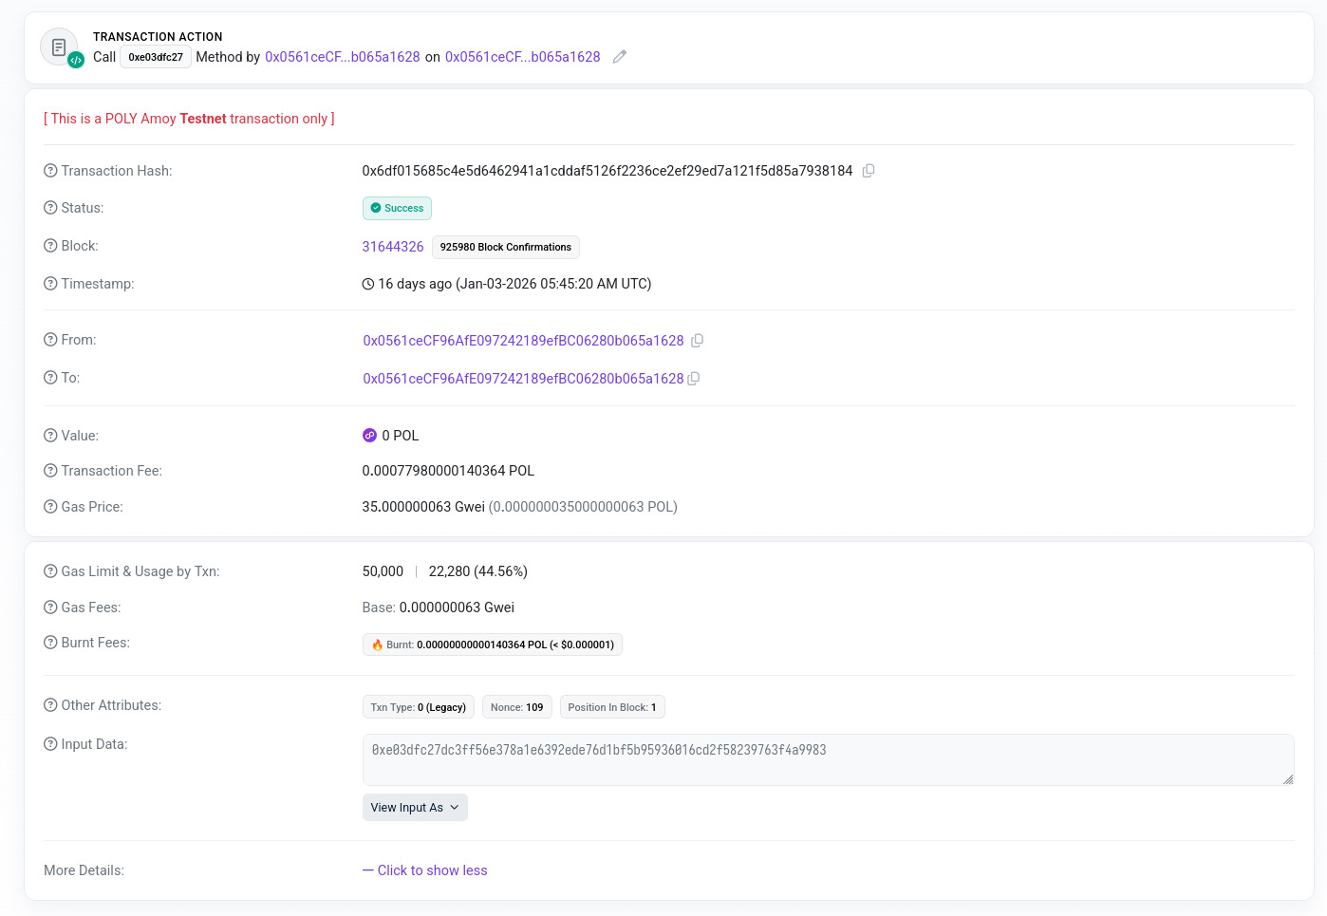
- S3 stored signed evidence bundle and release packages.
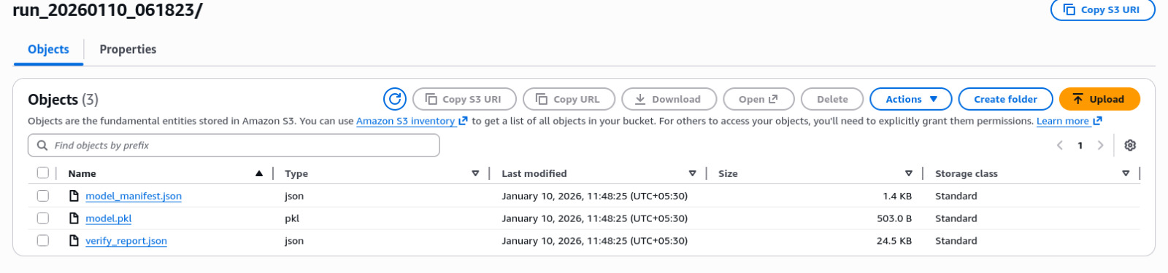
- EC2 verification output (MATCH / FAIL).
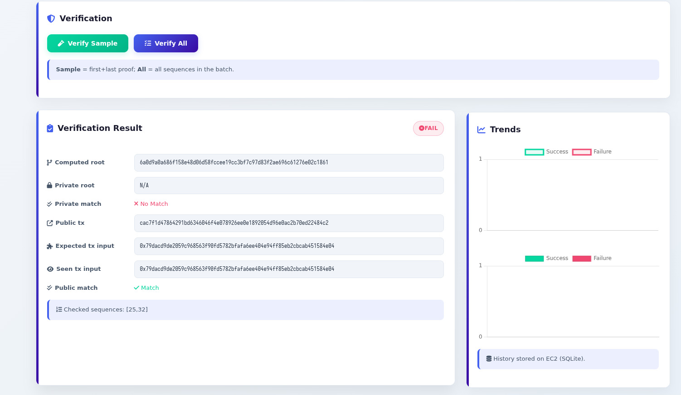
- AWS IoT Job execution status (Queued -> In Progress -> Succeeded/Failed).
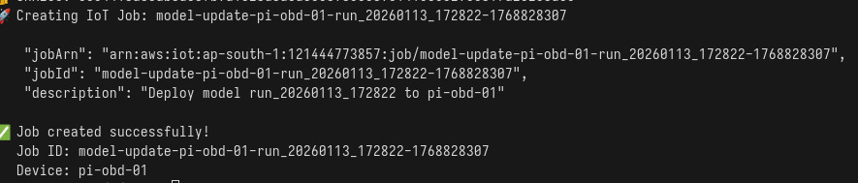
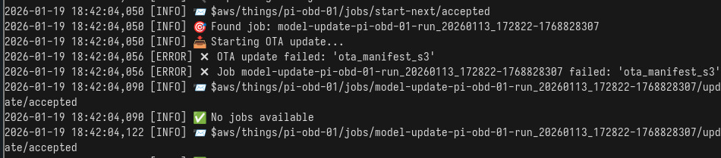
- Device-side logs for update verification (signature/hash validation).
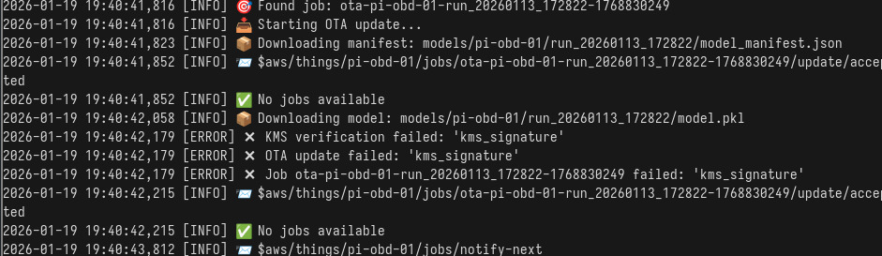

7. Compliance Mapping - UNECE R155 (CSMS Alignment)
UNECE R155 requires a Cyber Security Management System (CSMS). In a hackathon setting, we demonstrate CSMS-aligned technical controls and evidence outputs that support OEM cybersecurity objectives.
R155 Control Area | Unified Logic Implementation | Judge/Demo Evidence
Risk-based cybersecurity controls | Integrity proofing + verification pipeline | Merkle root, verification logs
Tamper detection | Mismatch detection via recomputation | FAIL status when record modified
Traceability | Batch ID + TxID linking (private + public) | Manifest entry + Polygon TxID
Secure key usage | KMS-protected signing/crypto operations | Signed artifacts + KMS configuration
Monitoring & incident evidence | Verifier outputs and IoT Job status logs | Cloud logs + device logs

8. Compliance Mapping - UNECE R156 (SUMS Alignment)
UNECE R156 requires a Software Update Management System (SUMS). Our OTA pipeline demonstrates secure update delivery, integrity validation, and traceable update records.
R156 Requirement | Unified Logic Implementation | Judge/Demo Evidence
Update authenticity | Signed release package | Pi rejects invalid signature
Update integrity | Hash validation before install | Hash match log
Controlled distribution | AWS IoT Jobs over MQTT | IoT Job created and received
Execution feedback | Job status reported to IoT Jobs | Succeeded/Failed job state
Traceability | Device ID + version + job ID record | Update record screenshot

9. Compliance Mapping - ISO/SAE 21434 (Engineering Evidence)
ISO/SAE 21434 focuses on cybersecurity engineering work products. For hackathon proof, we present the minimum set of deliverables and how judges can verify them during the demo.
ISO/SAE 21434 Work Product | What We Produced | How Judges Verify
Item Definition | System scope + interfaces | Architecture diagram + flow
Asset Inventory | Data, keys, manifests, update artifacts | Asset list in this document
Threat Analysis (TARA) | Attack scenarios + mitigations | Threat table + mitigations
Cybersecurity Requirements | Integrity + OTA security requirements | Requirements list
Verification & Validation | Tamper test + invalid update test | Pass/Fail demo evidence

10. Threat Scenarios and Mitigations (Hackathon TARA Summary)
The following realistic threats were considered and mitigated through implemented controls:
Threat Scenario | Mitigation | Control Component
OBD data injection / spoofing | Merkle-root mismatch detection when recomputed | Integrity verification (EC2)
Manipulation before batching on Pi | Batch integrity recomputation fails | Verifier MATCH/FAIL
Replay of old batches / old TxID | Batch ID + timestamp linkage; evidence traceability | Private manifest + Tx reference
Tampering with manifest stored in S3 | Signed evidence bundle validation | Signature verification
Unauthorized OTA update pushed to Pi | IoT policy control + signature checks | Job authorization + reject invalid
Downgrade attack (older software) | Version gating and deny outdated packages | Update policy + manifest version

12. Limitations (Transparent Statement for Hackathon)
- This is a hackathon prototype aligned to standards; it is not formally certified by a regulatory authority.
- OEM-level CSMS and SUMS governance processes (audit programs, supplier contracts) are outside hackathon scope.
- Full vehicle-level safety impact analysis and large-scale fleet rollout controls are future work.

13. Conclusion
Unified Logic demonstrates compliance-driven engineering by implementing tamper-evident data integrity proofs and secure OTA update management. The design aligns with UNECE R155 (cybersecurity), UNECE R156 (software updates), and ISO/SAE 21434 (engineering lifecycle) through cryptographic controls, traceability, and verifiable evidence artifacts.

